**FOOD WORLD (Virtual Kitchen Assistant App)**

**Naan Mudhalvan Project**

Submitted in partial fulfillment of the requirement for the award of

**BACHELOR OF COMPUTER SCIENCE**

Submitted By

**G.KAVIARASU-asunm110222201156**

**I.ASWIN KUMAR- asunm110222201140**

**B.ARAVIND KUMAR- asunm110222201138**

**B.ANBU- asunm110222201136**



**UG DEPARTMENT OF COMPUTER SCIENCE**

**DHARMAMURTHI RAO BAHADUR CALAVALA CUNNAN CHETTY’S**

**HINDU COLLEGE [SHIFT-II]**

**“LINGUISTIC (TELUGU) MINORITY STATUS**

**CONFERRED BY THE GOVT.OF.TAMIL NADU”**

**Re-Accredited by NAAC –Affillated to the University of Madras**

**Dharmamurthi Nagar, Pattabiram ,Chennai-600072**

**DECLARATION**

I am **G.KAVIARASU** (NM Id:-asunm110222201156).Hereby declare that the Nan Mudhalvan project work title “**FOOD WORLD (Virtual Kitchen Assistant App)**” submitted to the UG Department of Computer Science, SMARTINTERZN in partial fulfillment of the requirement for the award of Bachelor of Computer Science.

I am **I.ASWIN KUMAR** (NM Id:- asunm110222201140). Hereby declare that the Nan Mudhalvan project work title “**FOOD WORLD (Virtual Kitchen Assistant App)**” submitted to the UG Department of Computer Science, SMARTINTERZN in partial fulfillment of the requirement for the award of Bachelor of Computer Science.

I am **B.ARAVIND KUMAR** (NM Id:- asunm110222201138).Hereby declare that the Nan Mudhalvan project work title “**FOOD WORLD (Virtual Kitchen Assistant App)**” submitted to the UG Department of Computer Science, SMARTINTERZN in partial fulfillment of the requirement for the award of Bachelor of Computer Science.

I am **B.ANBU** (NM Id:- asunm110222201136).Hereby declare that the Nan Mudhalvan project work title “**FOOD WORLD (Virtual Kitchen Assistant App)**” submitted to the UG Department of Computer Science, SMARTINTERZN in partial fulfillment of the requirement for the award of Bachelor of Computer Science.

**TABLE OF CONTENTS**

|  |  |
| --- | --- |
| S.no | CONTENTS |
| 1 | INTRODUCTION |
| 2 | CONTENT OF THE PROJECT |
| 3 | PROJECT GOALS AND OBJECTIVES |
| 4 | PRE-REQUISITES |
| 5 | PROJECT STRUCTURE |
| 6 | SOURCE CODE |
| 7 | SCREENSHOT |
| 8 | CONCLUSION |

INTRODUCTION:

A cookbook is a collection of recipes, instructions, and information about the preparation and serving of foods.

PURPOSE OF COOK BOOK:

Cookbooks serve as a resource for home cooks, chefs, and anyone interested in exploring new recipes and culinary techniques.

All kinds of recipes are inside the cookbook! Students were told that they could bring in any type of recipe that they wanted and was something they (or their parents) had made before and enjoyed.

The categories included:

* Breakfast/ Drinks
* Appetizers
* Snacks
* Lunches
* Dinners
* Desserts

CONTENT:

They typically include a range of dishes, from appetizers to desserts, and may also feature tips on cooking techniques, ingredient substitutions, and meal planning.

This is specifically used for students and beginner to cook whatever they want to eat and other some purposes.

VARIATIONS:

Cookbooks can be general or specialize in a particular cuisine or category of food. Some are didactic, with detailed recipes for beginners, while others are simple aide-memoires, documenting the composition of a dish or precise measurements.

IMPORTANCE OF COOK BOOK:

* This is specifically used to know about dishes and their recipes.
* User can also this cook book without any confusion.

INSTRUCTIONS:

They provide detailed instructions on how to prepare and cook food, including ingredient lists, measurements, and step-by-step procedures.

BENEFITS:

* It can be a source of inspiration for new and creative dishes. It can help you to improve your cooking skills and learn new techniques, as many cookbooks include tips and tricks from professional chefs.
* A cookbook can also be a great way to preserve family recipes and pass down traditions to future generations.
* Improve Overall Nutrition
* Healthier Choices
* Higher Quality Meals
* Save Time & Energy
* Very simple

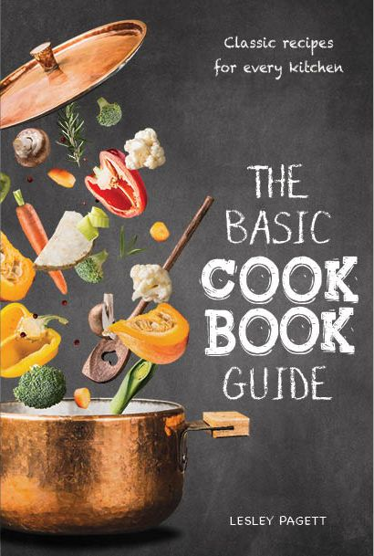

* There are n number of recipes available in this cook book.
* It is a collection of different exotic dishes.
* It also helps beginner to cook without any confusion.

Project goal and objectives:

The primary goal of cook book is used to make delicious and exotic dishes in correct measurement and different recipes.

User friendly interface:

Develop an intuitive interface that allows user to explore different dishes ,save, enjoy and can also share with their friends and families.

Key Features:

* Food collection: cook book contains multiple dishes with their recipes.
* Favorites: User can also save their favorite dishes using the option saved or favorites.
* Cook book measurement: Every measurement and recipes was stored with their dishes. So user can know every measurement about every dishes.
* Information: If you want to know about specific dish and their ingredients and duration time are also stored inside this app. At the same time it is in easily understandable way. so the beginner can also access.

PRE-REQUISITES:

Here are the key prerequisites for developing a frontend application using React.js:

* Node.js and npm:

Node.js is a powerful java script runtime environment that allows you to run java script code on the local environment.

* It provides a scalable and efficient platform for building network applications.

Install Node.js and npm on your development machine, as they are required to run java script on the server-side.

React.js:

* React.js is a popular java script library for building user interfaces.
* It enables developers to create interactive and reusable UI components, making it easier to build dynamic and responsive web applications.

Install React.js, a java script library for building user interfaces.

HTML, CSS and java Script: Basic knowledge of HTML for creating the structure of your app, CSS for styling, and java script for client-side interactivity is essential.

Project Structure:

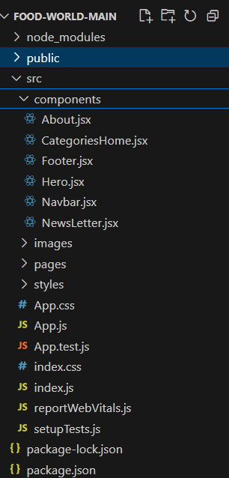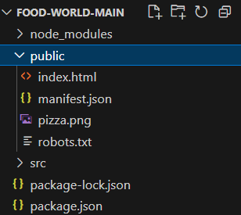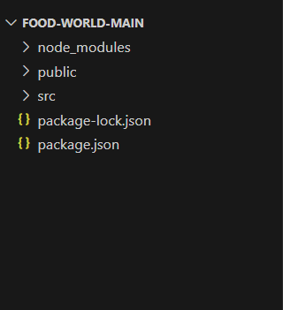The project structure may vary depending on the specific library, framework, programming language, or development approach. It’s essential to organize the files and directories in a logical and consistent manner to improve code maintainability and collaboration among developers.

**Source code:**

**Index.html:**

<!DOCTYPE html>

<html lang="en">

  <head>

    <meta charset="utf-8" />

    <link rel="icon" href="%PUBLIC_URL%/pizza.png" />

    <meta name="viewport" content="width=device-width, initial-scale=1" />

    <meta name="theme-color" content="#000000" />

    <meta

      name="description"

      content="Web site created using create-react-app"

    />

    <link rel="apple-touch-icon" href="%PUBLIC_URL%/pizza.png" />

    <!--

      manifest.json provides metadata used when your web app is installed on a

      user's mobile device or desktop. See https://developers.google.com/web/fundamentals/web-app-manifest/

    -->

    <link rel="manifest" href="%PUBLIC_URL%/manifest.json" />

    <!--

      Notice the use of %PUBLIC_URL% in the tags above.

      It will be replaced with the URL of the `public` folder during the build.

      Only files inside the `public` folder can be referenced from the HTML.

      Unlike "/favicon.ico" or "favicon.ico", "%PUBLIC_URL%/favicon.ico" will

      work correctly both with client-side routing and a non-root public URL.

      Learn how to configure a non-root public URL by running `npm run build`.

    -->

    <title>Food World</title>

  </head>

  <body>

    <noscript>You need to enable JavaScript to run this app.</noscript>

    <div id="root"></div>

    <!--

      This HTML file is a template.

      If you open it directly in the browser, you will see an empty page.

      You can add webfonts, meta tags, or analytics to this file.

      The build step will place the bundled scripts into the <body> tag.

      To begin the development, run `npm start` or `yarn start`.

      To create a production bundle, use `npm run build` or `yarn build`.

    -->

  </body>

</html>

**Manifest.json:**

{

  "short_name": "React App",

  "name": "Create React App Sample",

  "icons": [

    {

      "src": "favicon.ico",

      "sizes": "64x64 32x32 24x24 16x16",

      "type": "image/x-icon"

    },

    {

      "src": "logo192.png",

      "type": "image/png",

      "sizes": "192x192"

    },

    {

      "src": "logo512.png",

      "type": "image/png",

      "sizes": "512x512"

    }

  ],

  "start_url": ".",

  "display": "standalone",

  "theme_color": "#000000",

  "background_color": "#ffffff"

}

**Index.js:**

import React from 'react';

import ReactDOM from 'react-dom/client';

import './index.css';

import App from './App';

import reportWebVitals from './reportWebVitals';

import { BrowserRouter } from 'react-router-dom';

const root = ReactDOM.createRoot(document.getElementById('root'));

root.render(

  <React.StrictMode>

    <BrowserRouter>

      <App />

    </BrowserRouter>

  </React.StrictMode>

);

// If you want to start measuring performance in your app, pass a function

// to log results (for example: reportWebVitals(console.log))

// or send to an analytics endpoint. Learn more: https://bit.ly/CRA-vitals

reportWebVitals();

**App.js**

import './App.css';

import Navbar from './components/Navbar';

import Footer from './components/Footer';

import { Route, Routes } from 'react-router-dom';

import Home from './pages/Home';

import Category from './pages/Category';

import Recipie from './pages/Recipie';

function App() {

  return (

    <div className="App">

     <Navbar />

     <Routes>

      <Route path="/" element={<Home />} />

      <Route path="/category/:id" element={<Category />} />

      <Route path="/recipie/:id" element={<Recipie />} />

     </Routes>

     <Footer />

    </div>

  );

}

export default App;

**SCREENSHOT:**

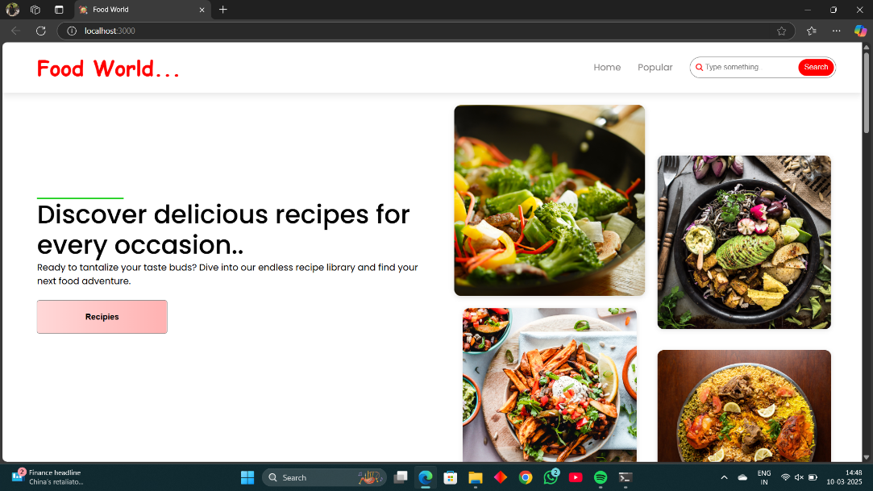

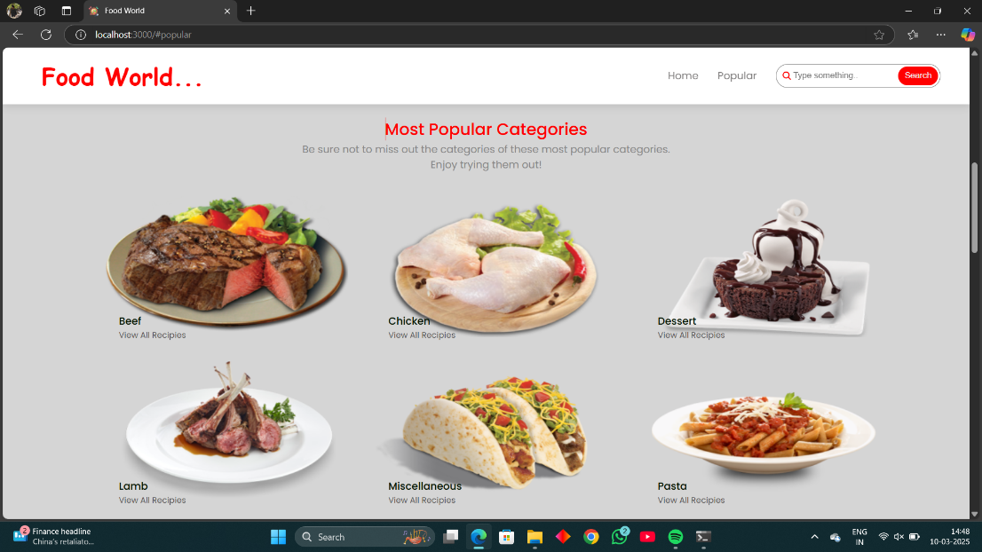

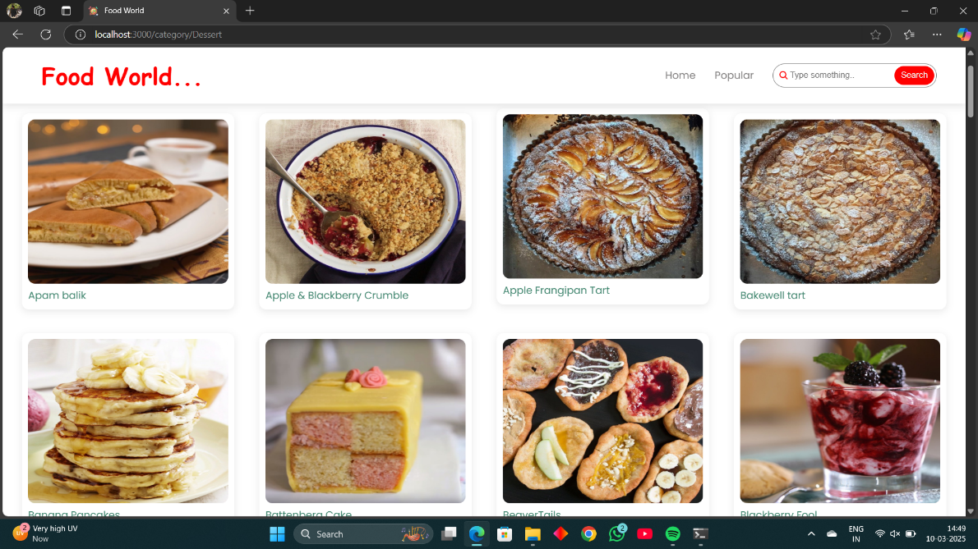

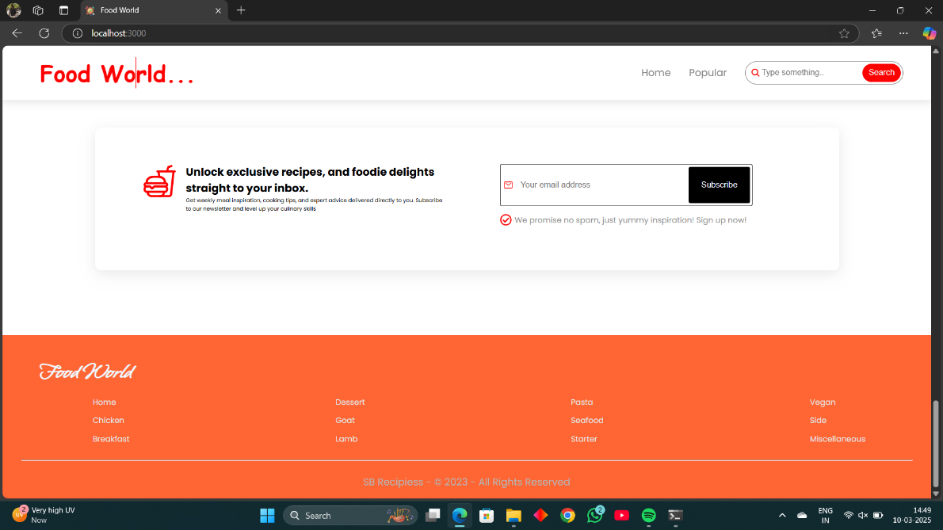

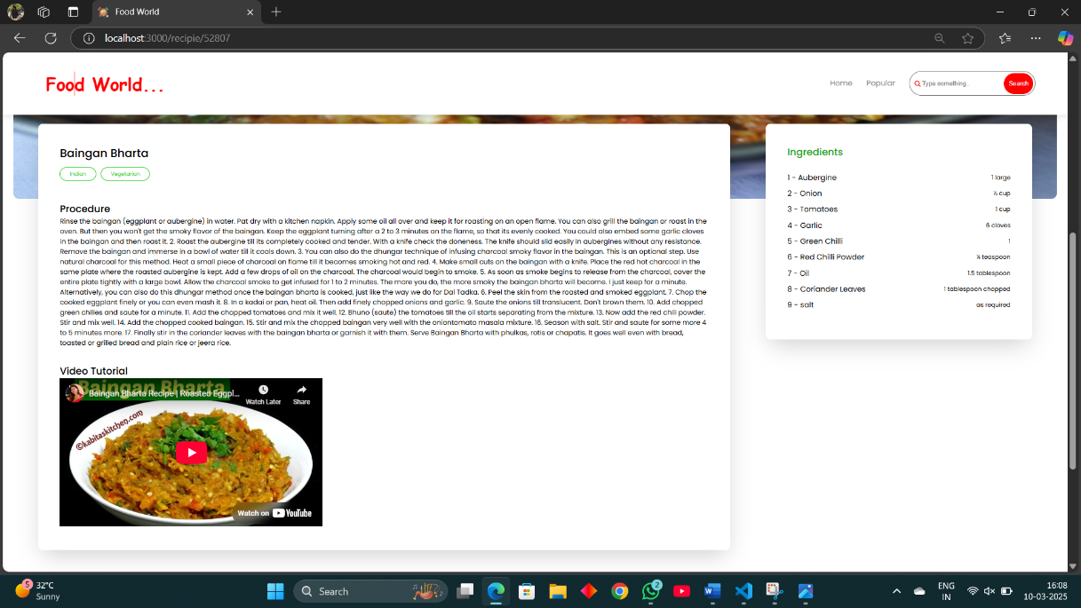

CONCLUSION:

In conclusion, cooking is not just about preparing meals; it’s about bringing people together, exploring new flavors, and expressing creativity. Whether you’re a beginner or an experienced chef, there’s always something new to discover in the kitchen. With the right tools, ingredients, and a bit of passion, you can transform everyday cooking into something extraordinary. So, don’t hesitate to experiment, try new recipes, and most importantly, enjoy the process. Let every dish you create be a reflection of your love for food and the joy it brings to those you share it with. Happy cooking!.